Finding the Pre-exponential Factor and Activation Energy of the Diffusion of Methylene Blue Through Dialysis Tubing to Determine the Effects of Feverish Body Temperatures on Drug-Eluting Hydrogel Implants
Candidate Code: mhj677
Word Count: 4061
Research question
To what extent do temperatures ranging from 20-75*C affect the rate of diffusion of methylene blue through the semi-permeable membrane of drug-eluting hydrogel implants fitted to experimental data from dialysis tubing?

Introduction
As someone who has an intense passion for chemical engineering, learning chemical engineering through computer simulations has been one of my favourite things to do. For the past month, I have been spending a significant amount of time working on my finite volume method codebase in the coding language Julia. However, for a simulation to be useful, it must mirror reality closely. To test how close my solver is to the real world, I will be performing multiple experiments testing the relationship between the rate of diffusion and temperature to fit my simulation to. Once this is done, I will use this data to model diffusion of molecules with similar molecular weight to methylene blue through the membrane of drug-eluting hydrogel implants. This is ideal because it will force me to evaluate both the limitations of my experiment and my simulation which cause inaccuracies in my simulation of the membrane of drug-eluting hydrogel implants.

Background Information
To model the rate of diffusion through the membrane of drug-eluting hydrogel implants, the rate of diffusion through the dialysis tubing will be measured at different temperatures. Using this data, a digital twin of the experimental setup can be constructed in my finite volume method codebase to optimize for the pre-exponential factor and activation energy that best fits the experimental data. Using the optimized pre-exponential factor and activation energy, the diffusion of methylene blue (acting as a proxy for other drugs with similar properties such as antibiotics like Ampicillin or anesthetics like lidocaine) from the implant to the surrounding tissue will be simulated at a non-fever temperature of 37°C and a fever temperature of 40°C. Then, the methylene blue concentration next to the implant will be compared to see if a patient having a fever will be at risk of receiving too high of a dosage due to the increased rate of diffusion.
This experiment was chosen because it provides the cleanest data for seeing how the simulation stacks up to the real world. Unlike other potential labs, acquiring precise concentration data is relatively easy through the use of a colorimeter compared to other methods like titration, digital concentration meters, pH meters, etc. Furthermore, the experiment itself takes very little time to complete, allowing for a large amount of samples to be collected, reducing uncertainty.
In terms of how this experiment relates to drug-eluting hydrogel implants, these implants have a similar structure to dialysis tubing and are typically implanted into a patient to continuously release a drug to a specific area. However, the rate at which the drug is dispensed can vary due to the patient’s fluctuating body temperature such as if they had a fever where body temperatures hover around ~39°C or are at normal body temperature ~37°C. Methylene blue was the ideal choice for this as it has a similar molecular weight to many different drugs used in drug-eluting hydrogel implants.
To briefly explain the methods used in this IA, traditionally, calculating the activation energy and pre-exponential factor for a system such as this requires keeping the temperatures and initial concentrations constant. My simulation bypasses this limitation by allowing fluctuating conditions to be accounted for. To do this, I created a 3D digital model of the dialysis tubing using CAD software and converted it into a mesh to be used by the solver. Then, I used my project FVMFramework to simulate how methylene blue diffuses through the mesh over time. Finally, I used an optimization algorithm using gradients to compare my simulation’s predictions against my actual experimental data. By calculating the error between the two, the algorithm can automatically fine-tunes the pre-exponential factor and activation energy until it finds the parameters that best match reality.

Variables
Independent Variable (IV): The body temperature surrounding the drug-eluting hydrogel implants.

Dependent Variable (DV): The rate of diffusion through the membrane of a simulated drug-eluting hydrogel implant fitted to processed data collected in the initial experiment.

Controlled Variables
Table 1: Controlled Variables
Control Variable | Unit | Method For Control | Reason for Control
Initial concentration of methylene blue present in dialysis tubing | M | A standard solution of known concentration will be prepared to be used for all trials. | If some trials had a higher concentration of methylene blue for instance, the methylene blue would appear to diffuse faster than it should.
MWCO (molecular weight cutoff) of dialysis tubing | Da | The same MWCO of dialysis tubing will be used. | Lower MWCO dialysis tubing creates a more torturous path for smaller molecules, which limits the rate of diffusion.
Length and diameter of dialysis tubing used (controlling for surface area) | m | A ruler will be used to precisely measure the length of the dialysis tubing | Even if the same amount of moles of methylene blue was used for larger diameters or longer sections of dialysis tubing, there is still more surface area of semi-permeable membrane for methylene blue to diffuse across, which would increase the rate of diffusion.
Volume of water surrounding the dialysis tubing | L | In addition to writing down the exact amount of water used for each trial, the bottom of the meniscus of the water for the first trial will be marked and aimed for other trials. | If there was a smaller volume of water that surrounded the dialysis tubing, the methylene blue would be more concentrated after it completely diffuses, making the methylene blue appear more concentrated than it actually is.
Location where the methylene blue is withdrawn |  | A spot will be marked with a black sharpie halfway up the beaker where the mixture will be consistently drawn from. | Withdrawing from random locations is problematic because there’s a gradient from high to low methylene blue concentration from the dialysis tubing, meaning samples withdrawn closer to the dialysis tubing will contain a higher concentration of methylene blue.
Stir bar speed | RPM | The RPM set on the hotplate will be recorded and set to the same value between trials. | If the solution was stirred more vigorously for one trial, the methylene blue would diffuse more quickly into the solution outside the tubing due to the more vigorous stirring decreasing the concentration gradient from the outermost layer of the tube to other parts of the solution.

Hardware and Materials
Chemicals
- 50 ml of 1% methylene blue
- 10 L of distilled water

Hardware
- 1x 1 L flask
- 1x 500 ml flask
- 2x 1 L volumetric flask
- 1x 5 ml volumetric pipette
- 4x 50 ml burettes
- 3x 100 ml volumetric flask
- 100 cm of 2 cm diameter dialysis tubing
- 2x Dialysis tubing clamps/closures
- Retort stand to hold dialysis tubing
- Digital thermometer
- Retort stand with clamp to hold thermometer
- Colorimeter
- Ruler
- 2 Iron stands
- Hot plate with a stir function
- Stir bar
- A non-essential timer (not a phone)
- A set of calipers to measure the real diameter and height of the dialysis tubing after it has been filled with methylene blue solution.
- Balance with a max weight of around 1 kg or more, as accurate as possible.

Methodology
Creating a Standard Solution,
- To create Solution A, use a 50 ml burette and balance to precisely place 40g of 1% methylene blue into a 1 L volumetric flask and fill the flask to the line with distilled water (this is the solution that will be placed in the dialysis tubing)

Calibrating the colorimeter
- Place another 1 L volumetric flask on the balance, withdraw ~40 ml of methylene blue mixture from the first 1 L volumetric flask and dispense as close to 40 g as possible into the new 1 L volumetric flask. Fill it to the line. (100%)
- Withdraw 5 ml of this solution, analyze it in the colorimeter and record your results.
- Place a 100 ml volumetric flask on a balance, withdraw 75 ml of calibration stock and place it in a 100 ml volumetric flask until the balance reads 75 g, fill to the line with distilled water. (75%)
- Withdraw 5 ml of this solution, analyze it in the colorimeter and record your results.
- Place another 100 ml volumetric flask on a balance, withdraw 50 ml of calibration stock and place it in a 100 ml volumetric flask until the balance reads 50 g, fill to the line with distilled water. (50%)
- Withdraw 5 ml of this solution, analyze it in the colorimeter and record your results.
- Place another 100 ml volumetric flask on a balance, withdraw 25 ml of calibration stock and place it in a 100 ml volumetric flask until the balance reads 25 g, fill to the line with distilled water. (25%)
- Withdraw 5 ml of this solution, analyze it in the colorimeter and record your results.
- Wash out the colorimeter cuvette thoroughly with distilled water
- Finally, withdraw 5 ml of distilled water and analyze it in the colorimeter and record your results. (0%)

Procedure
- Using a ruler, measure and cut 5 10 cm segments of dialysis tubing.
- Before submerging each section of dialysis tubing, weigh each section of dialysis tubing
- Submerge each dialysis tubing section in distilled water for 15 minutes to rehydrate and soften them
- Before the section of dialysis tubing is filled, weigh each section of dialysis tubing again and record your results.
- Before each trial, clamp one end of the dialysis tubing and pipette enough of solution A to make the dialysis tubing turgid (like a filled sausage). Clamp the other end and make sure it’s tight. Measure the real diameter at the middle of the tubing and the height from both ends of the dialysis tubing (the thinnest part) and record this data.
- Weight the section of dialysis tubing again with the methylene blue solution in it.
  - A reference photo with a ruler would also be helpful to nail down the geometry of the dialysis tubing later
- For each trial:
  - Thoroughly wash out the 1 L volumetric flask used for calibrating the colorimeter and fill it with 1 L of distilled water and pour it into the 1 L beaker.
  - Using the retort clamp and iron stand, place your thermometer so that it’s halfway between the dialysis tubing and the wall of the beaker. Make sure the thermometer’s probe is as close to the bottom of the beaker as possible.
  - Turn on your plate, turn on the stirring and adjust the heat input dial until the temperature of the solution reaches room temperature for the first trial, 50°C for the second trial, and 70°C for the third trial.
  - Submerge your dialysis tubing in the 1 L beaker.
  - At each timestamp (0:30, 3:00, 6:00, 9:00, 12:00, 15:00, 20:00, 25:00, 30:00)
(9 total):
    - Use a 5-10 ml pipette to withdraw 5 ml of methylene blue at the midline at the edge of the beaker, analyze it in the colorimeter and record your results.
    - Pour the volume of solution in the colorimeter cuvette back into the beaker
    - Note: if you do not have enough cuvettes for every timestamp, do not wash the the cuvette after you dump it, just leave the small film of methylene blue solution in it

Raw Data and Data Processing
Condensed Raw Data
Table 1: Timestamps, Temperatures, and Sampled Solution Absorbance at each time interval.
Trial 1 |  |  | Trial 2 |  |  | Trial 3
Time (s) | Temperature  (°C) | Sampled Solution Absorbance | Time (s) | Temperature  (°C) | Sampled Solution Absorbance | Time (s) | Temperature  (°C) | Sampled Solution Absorbance
60 | 57.1 | 0.06 | 60 | 71.3 | 0.06 | 60 | 19.2 | 0.025
210 | 56.6 | 0.113 | 180 | 72.4 | 0.10 | 180 | 19.2 | 0.034
360 | 56.3 | 0.16 | 360 | 72.5 | 0.17 | 360 | 19.2 | 0.0475
540 | 56.1 | 0.206 | 540 | 71.2 | 0.24 | 540 | 19.3 | 0.065
720 | 55.9 | 0.245 | 720 | 69.7 | 0.29 | 720 | 19.3 | 0.092
900 | 55.7 | 0.286 | 900 | 71 | 0.33 | 900 | 19.4 | 0.107
1080 | 55.6 | 0.318 | 1080 | 74.2 | 0.37 | 1080 | 19.4 | 0.108
1260 | 55.5 | 0.366 | 1260 | 76.4 | 0.42 | 1260 | 19.5 | 0.1245
1440 | 55.4 | 0.384 | 1440 | 77.3 | 0.44 | 1440 | 19.5 | 0.153
 |  |  | 1620 | 77.9 | 0.48 | 1620 | 19.6 | 0.161

Intermediate Data Processing
Beyond the simulation, the only data processing needed for this IA is determining the initial mass fraction of methylene blue in the dialysis tubing and the mass fraction of methylene blue present in each calibration mixture. To convert the calibration mass fractions to the experimental mass fractions, an interpolation using the DataInterpolations Julia package was made to correlate the absorbances of the known mass fractions of the calibration samples to the absorbances recorded at each time interval in the experiment.

For the solution that was added to the dialysis tubing, 40g of a 1% by mass methylene blue solution was added to 960 ml of water to make 1 L of solution.
$methylene blue mass = methylene blue initial mass fraction *solution mass$
0.4 g = 1.0% * 40.0 g
$methylene blue mass fraction= methylene blue mass / solution mass$
0.04% = 0.4 g / 1000 g

Then, 40g of the 0.04% methylene blue by mass solution was added to 960 ml of water to create the 100% calibration solution.
$methylene blue mass = methylene blue mass fraction * solution mass$
0.016 g = 0.04% * 40.0 g
$methylene blue mass fraction= methylene blue mass / total solution mass$
1.6 × 10⁻⁵ = 0.016 g / 1000 g

Then, 25 g, 50 g, and 75 g of the same 0.04% methylene blue by mass solution was added to 75 ml, 50 ml, and 25 ml of water respectively which the interpolation was based on in addition to the 100% calibration solution.
(just showing one calculation for 25g of the 0.04% by mass methylene blue solution)
$methylene blue mass = methylene blue mass fraction * solution mass$
0.01 g = 0.04% * 25.0 g
$methylene blue mass fraction= methylene blue mass / total solution mass$
1.0 × 10⁻⁵ = 0.01 g / 1000 g

Results
Simulated vs Experimental Data
Chart 1: Trial 1 Experimental vs Simulated Methylene Blue Mass Fractions Over Time
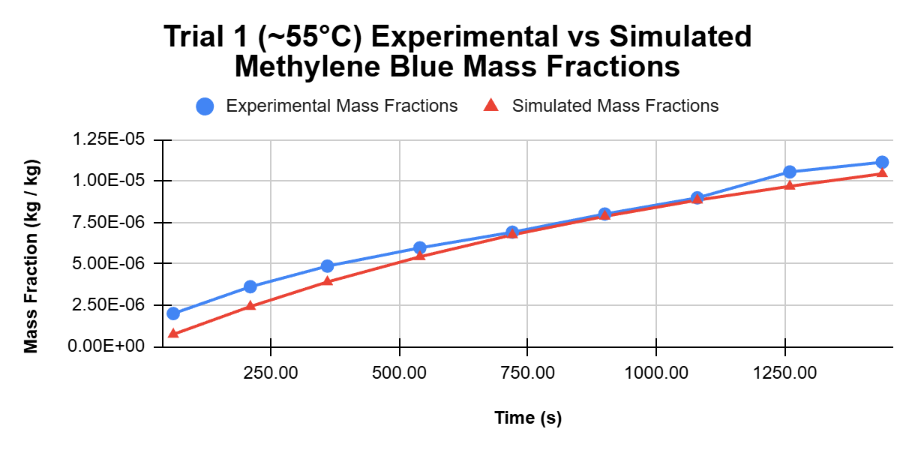

Chart 2: Trial 2 Experimental vs Simulated Methylene Blue Mass Fractions Over Time

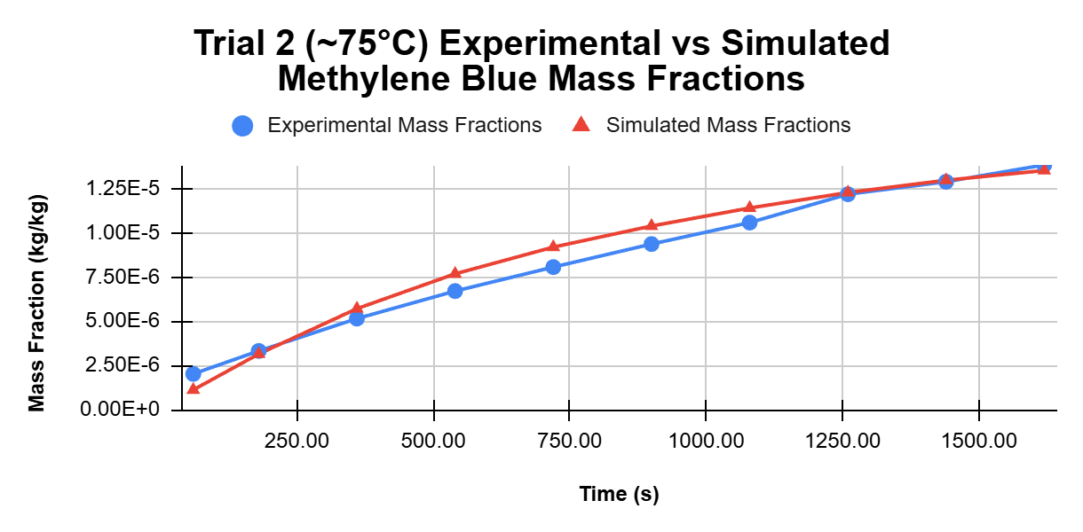

Chart 3: Trial 3 Experimental vs Simulated Methylene Blue Mass Fractions Over Time
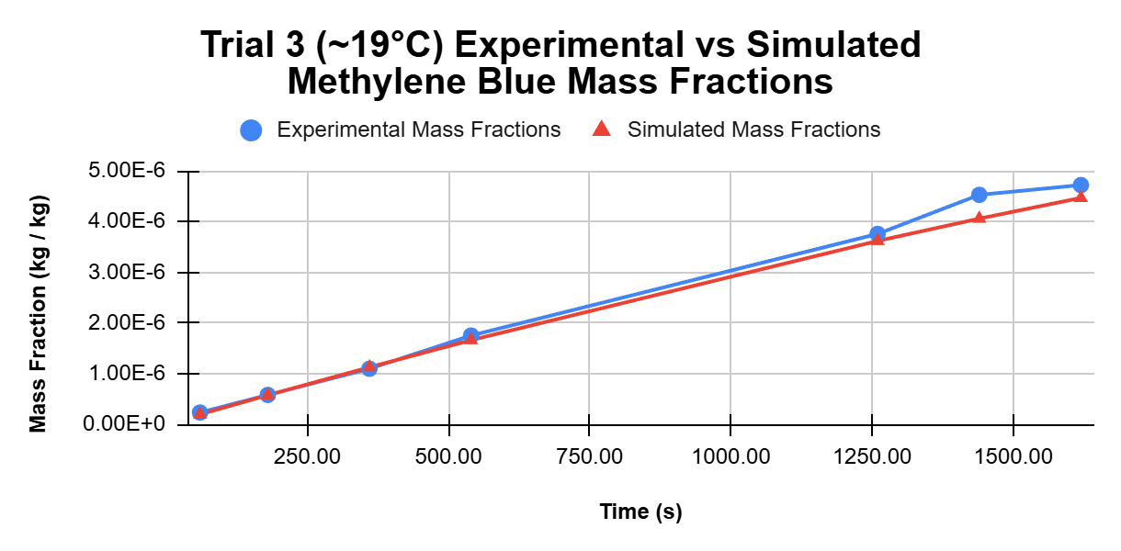
Note: The experimental data points between t = 550 to t = 1250 were dropped before doing parameter optimization due to them being extremely inaccurate due to the colorimeter giving bad measurements.

3D animations of these simulations can be viewed here or with this QR-code: 

Optimized Parameters
Optimized Permeability: 6.952 × 10⁻⁴ [m/s]
(Similar to diffusion coefficient that lumps in membrane thickness)

Optimized Diffusion Coefficient: 2.0857 × 10⁻⁸ [m²/s]
(Assuming the membrane of the dialysis tubing is 30 [µm] thick):

Optimized Activation Energy: 28.72 [kJ/mol]

Non-Fever vs Fever Results
Chart 4: Comparing Methylene Blue present in tissue immediately next to drug-eluting hydrogel implant by mass fraction
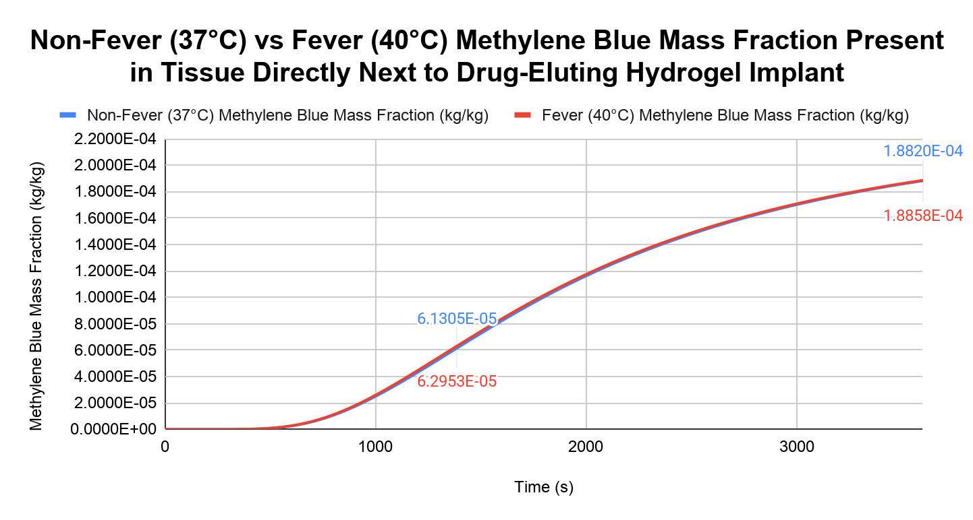

3D Animations of these simulations can be viewed here or with this QR-code (these are much more interesting to look at than the previous ones):

Conclusion
The goal of this investigation was to use experimental data to build a digital twin of the experiment in order to find the pre-exponential factor and activation energy of methylene blue crossing the dialysis tubing’s semi-permeable membrane to determine if the higher internal temperature during fevers would be problematic for drug delivery via drug-eluting hydrogel implants.
Based on the fact that the max absolute difference between the non-fever and fever simulation was only 1.6480 x 10⁻⁶, with a percent difference of 2.65%, the higher temperatures observed within the body during a fever do not seem to significantly increase the concentration of methylene blue delivered to the surrounding tissue. The confidence of this answer is strengthened by how well the optimized parameters fit the original experiment, both visually matching up very well in addition to having a very low Range-Normalized Root Mean Square Error (RMSE) of only 1.806% when comparing all data points between the experimental and simulated data. Furthermore, while the goodness of fit of the higher temperature trials are slightly questionable visually, the trial performed at ~19.0°C matches the data very well meaning that lower temperatures that are close to the temperature of the human body are likely more accurate.
That being said, the diffusion coefficient for methylene blue within the tissue itself was assumed to be constant at 1.0 x 10⁻⁸ [m²/s] while in reality, this coefficient would also vary with temperature, potentially leading to faster methylene blue diffusion in the real world. Also, while dialysis tubing and hydrogel membranes are relatively similar due to them both being hydrated polymer networks, they are made out of different materials. However, this likely is not an issue as hydrogel membranes generally have a lower activation energy which means that the rate of diffusion is affected less by temperature which means that the difference between the rate of diffusion between non-fever and fever temperatures would likely be even closer than it already is.
Evaluation
Weaknesses and Limitations of the Investigation
Weakness/  Limitation | Explanation | Improvements
Colorimeter data and use of an interpolation to correlate colorimeter data to methylene blue mass fraction. | While the data collected from the colorimeter remained consistent when the data was collected on the same day, after coming back to the colorimeter 3 days later, the measured absorbance for each calibration solution was far different than the absorbances measured on the first day. Because of this, trial 3 used a different interpolation than the first and second trial based on remeasuring the absorbances of each calibration solution. The actual effect that this has on the accuracy of the interpolation for trial 3 is uncertain, but it should still be noted just to prevent this uncertainty. | To fix this issue, the trials should either be performed on the exact same day where each measurement is much more likely to be accurate to one another or a more precise instrument like a spectrophotometer could be used.
Movement of dialysis tubing in methylene blue solution. | Due to the fact that the fluid surrounding the dialysis tubing was mixed using a stir bar, the dialysis tubing swung around in the beaker during each trial. While this is not that bad for finding the optimized activation energy, the optimized pre-exponential factor is most likely much higher than it otherwise would be if the dialysis tubing was still during the experiment due to the fact that advection (forced movement across the membrane) was likely occurring due to this. | There are two different ways this could be resolved. The first way would be to place something heavy like a 1 cm diameter steel ball bearing or a glass bead into the dialysis tubing to prevent it from swinging around from the mixing. The second and much harder way would be to use a moving mesh in the solver and account for the higher diffusion rate due to advection. While the first method is much more preferable, if this was performed on a multi-million dollar pilot plant where collecting data costs a significant amount of money, the second option would probably be much more preferable.
Unknown thickness of dialysis tubing. | The thickness of the membrane of the dialysis tubing was not mentioned in the specifications provided by the manufacturer. While this does not affect the accuracy of the optimized permeability, the optimized diffusion coefficient that is found by multiplying permeability by membrane thickness does become uncertain. This is problematic because if the dialysis tubing is thinner than expected, the optimized diffusion coefficient is likely to be lower than reality, which would reduce the rate of diffusion of methylene blue in the drug-eluting hydrogel implant simulation. | If this investigation was performed again, the dialysis tubing should be bought from a manufacturer that lists the thickness of the dialysis tubing or the original suppliers could be contacted to find its thickness.
Improper measurement of dialysis tubing leading to improper dimensions when translating it into a mesh. | Despite being a relatively simple process, two factors made translating the measurements of the dialysis tubing in the real world to the mesh used by the solver very hard to get right. The first issue was the measurements taken of the dialysis tubing during the experiment. When the dialysis tubing was filled with methylene blue in the experiment, the length of the end that is shaped like a cone was not measured. In the simulation itself, the cone at the end of the tubing was assumed to be 1.0 cm which was about what I remembered it to be. In addition to this, getting the volume and surface area of the dialysis tubing correct to the experiment with the constraints of meshes was also very challenging. Since the final equilibrium concentration of methylene blue depends on the initial volume of methylene blue present in the dialysis tubing, the volume used in the simulation had to match the experimental data. Due to the fact that the accuracy to the 3D model is determined by how fine the mesh is and that computational costs go up as mesh fineness goes up, getting the right balance between these two was hard. | There are two main ways this issue could be dissolved. The first option is slightly questionable as it would not be compatible with the moving mesh proposed above, since both the inside and outside of the dialysis tubing was assumed to be well-mixed, the dialysis tubing could be approximated with a flat wall that matches the dialysis tubing’s surface area in addition to two volumes on either side where one would match the internal volume of the inside of the dialysis tubing and while the other matches the fluid surrounding the dialysis tubing. The second option would be to implement second-order meshes in my solver which allows the use of second-order meshes which are basically meshes where the lines that make up each cell can be curved to better approximate curved surfaces like the outside of the dialysis tubing used in this investigation with fewer cells.  Here’s a good example of the difference between the two:  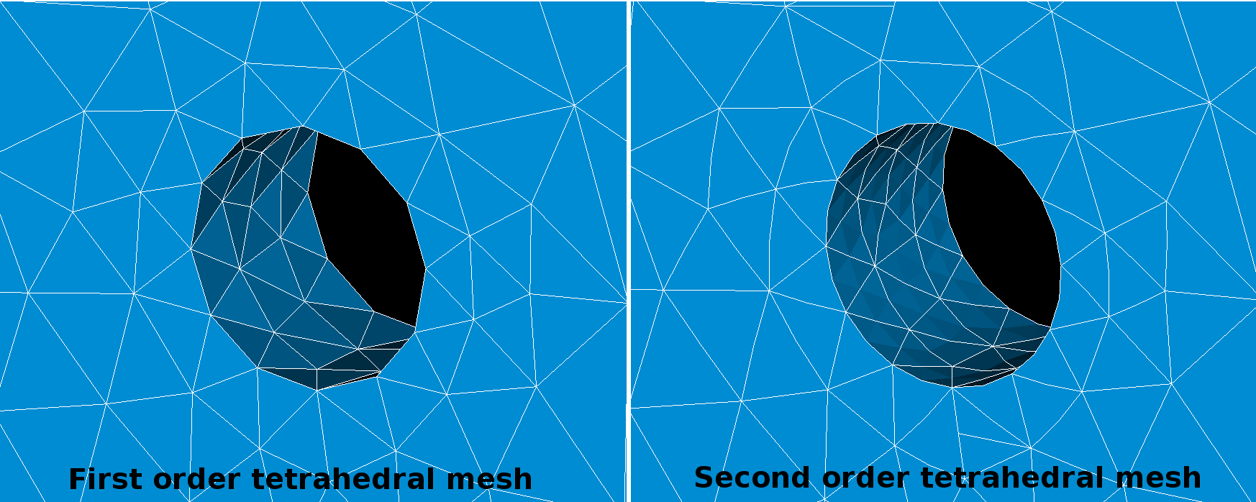  Image Source: https://www.simscale.com/forum/t/when-should-i-use-a-second-order-mesh/25899
Experimental trials were assumed to be well mixed in simulation. | Due to the use of a stir bar at rotating at around 500 rpm and due to the dialysis tubing’s movement, both the fluid surrounding the dialysis tubing as well as the inside of the dialysis tubing was assumed to be well-mixed. This was done due to the complexity of modeling the forced convection incurred by the stir bar. This would also be an issue if the dialysis tubing was kept fixed during the experiment due to the fact that the swirling currents around the dialysis tubing might cause the methylene blue to diffuse faster. While the impact of this on the data is unclear it likely only had minimal impact vs assuming both volumes were well mixed. | Similar to the moving dialysis tubing problem, this could also be resolved by modelling advective and convective forces within each volume. The reason the volume was mixed in the first place is that if it wasn’t there would be a significant gradient in methylene blue concentration between the fluid closest to the tubing and the fluid furthest away from the tubing. In addition, the lack of stirring would mean that the uncertain value of the diffusion coefficient methylene blue in pure water would also pollute the data. Furthermore, different temperatures would impart different amounts of natural convection in the water which would also pollute the data.
The pores within the dialysis tubing likely expanded as temperature rose. | The increased pore size due to the thermal expansion of the dialysis tubing is more accurately described as a part of the diffusion coefficient. While the activation energy that determines the rate of diffusion at different temperatures would lump this effect into itself, this effect is more accurately described as something affecting the diffusion coefficient directly at different temperatures. | To minimize this error, if the integral of all temperatures observed in the experiment over time matched the temperature that the data would be applied at, this effect would be minimized.
Inability to propagate uncertainty through the solver. | Due to the fact that propagating uncertainty calculations while the solver is being run is nearly impossible, the uncertainty of the values observed in the simulation cannot be applied to the final optimized pre-exponential factor and activation energy. | To alleviate this issue, a Monte Carlo approach could be used where the optimizer could be run multiple times where each point of experimental data is randomly chosen between its max value given its uncertainty and minimum value given its uncertainty and then by calculating the standard deviation of the optimized parameters from each run, the uncertainty of the final parameters could be calculated. This is great because uncertainty does not have to be propagated throughout the solver.

Appendix
AI declaration
- AI tools were used in:
  - Coming up with potential experiments where the data would be clean enough to do parameter optimization
    - The main reason I did this is that choosing an experiment that will yield useable data with how many options there are is extremely challenging
  - Coming up with potential topics where the optimized parameters that I found could be used to link this investigation back to something biological (ended up choosing drug-eluting hydrogel implants)
  - The debugging of code used in this investigation
    - Do note that I NEVER use AI to write code as it defeats the purpose of me writing code in the first place to not only implement the finite volume method and use it, but also to gain a better understanding of the finite volume method to make future work with more industry-standard applications like OpenFOAM or Ansys Fluent significantly easier.
    - However, I do use it for debugging as it can be very useful to find where you made slight errors that cause the simulations to be physically incorrect.
- AI tools were not used in:
  - The writing of this document
  - The writing of the code used in this investigation
  - Anything else not listed above

Other files of interest.
All of the raw data, code, 3D models, meshes, and some additional informal notes can be viewed in this (or from the QR Code below) directory in my project FVMFramework on github.
- The raw data can be viewed in the file dialysis_tubing_diffusion_data.xlsx


